
What Are the Benefits of a Star Schema and How Is It Used?
Course Name: CST8276 020

Professor:
Group Members:
Submission Date:

Introduction
The purpose of this project is to explore Star Schema and its advantages in database design. The Star Schema is widely used in data warehousing and business intelligence (BI) applications due to its simplified structure and faster query performance.
Additionally, we will compare Star Schema with Snowflake Schema, highlighting differences in performance, storage efficiency, and complexity. By developing both schemas, we will demonstrate their use in a real-world scenario.

Project Objectives
Our primary objectives include:
- Understanding the concept and structure of a Star Schema.
- Developing a Star Schema for a sample database.
- Developing a Snowflake Schema for comparison.
- Analyzing query performance and storage efficiency of both schemas.
- Providing use case scenarios where each schema is most effective.
- Concluding with recommendations for choosing the best schema in various business cases.

Research Scope & Methodology
Scope
- Focuses on dimensional modeling in database design.
- Compares Star Schema vs. Snowflake Schema in terms of performance and storage efficiency.
- Implementation of both schemas using SQL-based database (MySQL, PostgreSQL, or SQL Server).
- Performance testing using sample queries.

Methodology
- Step 1: Literature Review on Star and Snowflake Schema.
- Step 2: Selection of a business scenario for implementation (e.g., sales transactions, e-commerce, healthcare).
- Step 3: Designing Star Schema and Snowflake Schema using ER diagrams.
- Step 4: Implementing schemas in an SQL-based database.
- Step 5: Running benchmark tests on query speed and storage.
- Step 6: Analyzing the results and concluding findings.

Understanding Star Schema
Definition
- A Star Schema consists of a central fact table connected to multiple dimension tables, forming a star-like structure.
- A Star Schema is a denormalized database schema consisting of a central fact table connected to multiple dimension tables, forming a star-like structure.
- The fact table stores quantitative business metrics (e.g., sales revenue, units sold).
- The dimension tables store descriptive attributes (e.g., product details, customer information, time periods).
Structure
- Fact Table: Stores transactional data (e.g., Sales, Orders).
- Dimension Tables: Contain descriptive data (e.g., Date, Product, Customer, Location).
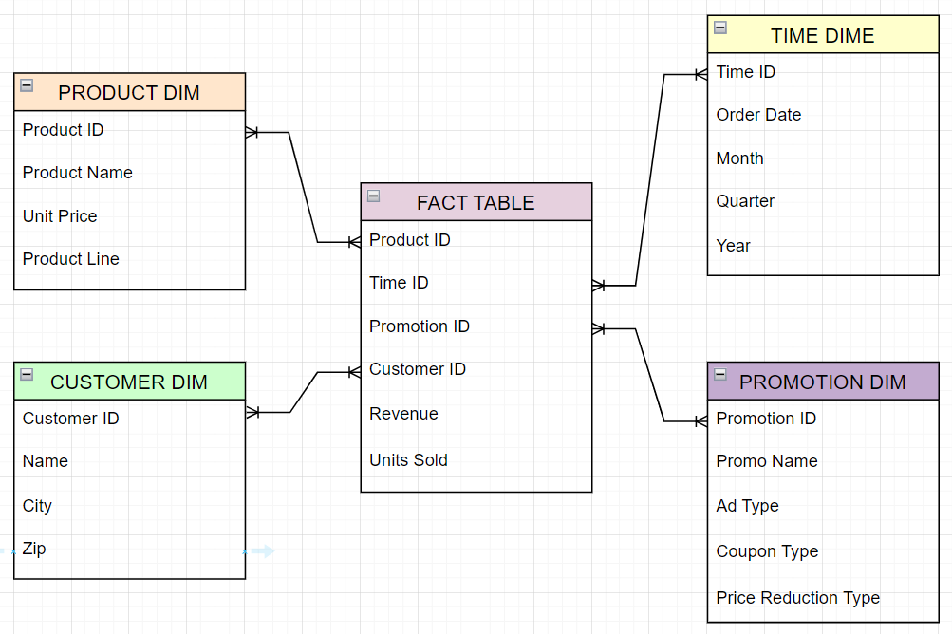
Advantages
- Simple & Easy to Understand
  - Queries are easier to write and understand.
  - Requires fewer joins compared to normalized schemas.
- Fast Query Performance (fewer joins)
  - Faster data retrieval as data is pre-aggregated.
  - Optimized for OLAP operations (aggregations, filtering, trend analysis).
- Ideal for Reporting and BI Tools
  - Supports fast analytics in tools like Tableau, Power BI, and SQL dashboards.
  - Efficient data visualization and trend analysis.

Understanding Snowflake Schema
Definition
- A Snowflake Schema is an extension of Star Schema, where dimension tables are normalized to reduce data redundancy.
Structure
- Fact Table
- Normalized Dimension Tables (Sub-tables for hierarchical data)
Advantages & Disadvantages
- Saves Storage Space
- Reduces Data Redundancy
- Increases Query Complexity (more joins required)
- Slower Performance for OLAP queries

Comparative Analysis
Feature | Star Schema | Snowflake Schema
Normalization | Denormalized | Normalized
Query Performance | Faster | Slower (More Joins)
Storage Efficiency | Higher Redundancy | Lower Redundancy
Ease of Use | Easier | More Complex
Best For | OLAP and Reporting | Complex Hierarchical Data

Schema Development Plan
Step 1: Choose Business Scenario
- Example: Retail Sales Database (tracking customer purchases).

Step 2: Star Schema Development
- Fact Table: Sales Transactions
- Dimension Tables: Customers, Products, Store Locations, Dates

Step 3: Snowflake Schema Development
- Normalizing the dimension tables (breaking them into multiple sub-tables).

Step 4: Implementing in SQL
- Creating schemas in MySQL or PostgreSQL.

Step 5: Query Performance Testing
- Running aggregated queries (e.g., total sales per month).

Expected Outcomes
Visual representations of Star and Snowflake Schemas.
SQL-based implementations demonstrating query performance.
Comparison of query execution time and storage usage.
Real-world recommendations on when to use Star vs. Snowflake Schema.

Team Roles & Responsibilities
Team members | Resposibility
Member 1 | Research on Star Schema
Member 2 | Research on Snowflake Schema
Member 3 | Schema Design (ERD, Normalization)
Member 4 | SQL Implementation
Member 5 | Query Performance Testing & Analysis
Member6 & Member 7 | Documentation & Reporting Writing

Timeline
Task | Deadline
Research Phase | Date
Schema Design (ERD) | Date
SQL Implementation | Date
Query Performance Testing | Date
Report & Presentation Preparation | Date

Conclusion
This project will provide a detailed analysis of Star Schema and Snowflake Schema, including their benefits, real-world applications, and performance differences. By developing both schemas and comparing them, we aim to provide clear insights into when to use each schema effectively

